9/24/2026
LAB NO 03
Operating System
Instructor: Ms. Muneeba Banaras
Submitted By: Wasif Ali
Reg ID: 245187
Class: BSCS F’24 B

LAB TASK
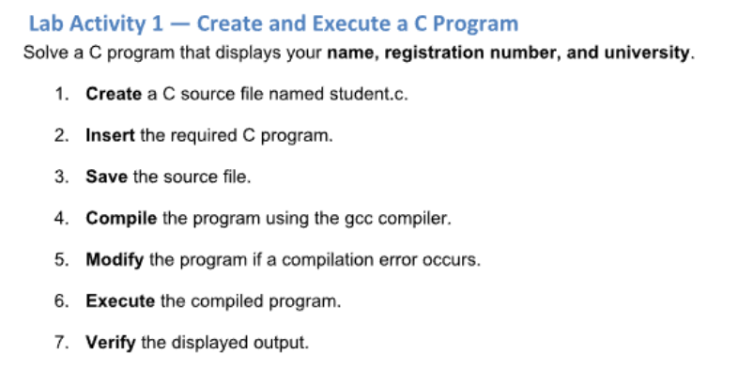

Working:
In this activity, we created a C source file named student.c using the nano editor. We wrote a program using the printf function to print personal details including name, registration number, and university name. Finally, we compiled the program using the gcc compiler into an executable file named student and executed it in the terminal to verify the output.

Commands and Output:
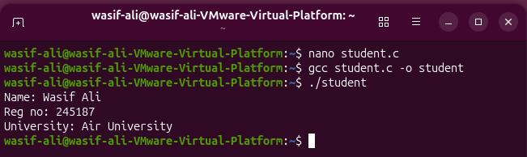
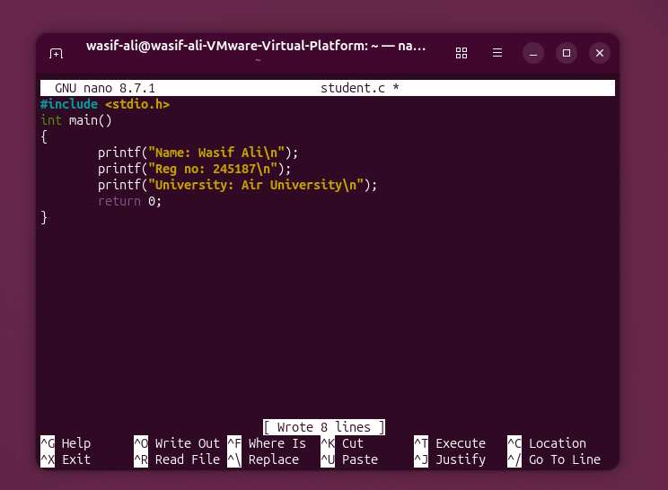

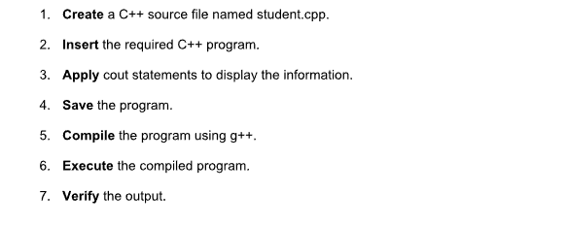

Working:
In this activity, we created a C++ source file named student.cpp. We utilized the standard cout output stream object to print personal information on the terminal. We then compiled the C++ code using the g++ compiler to create an executable binary and ran the program to display the result.

Output and Result:
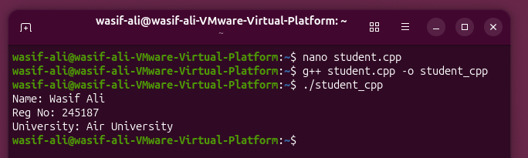
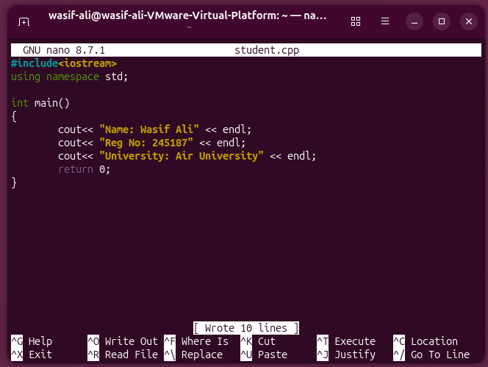

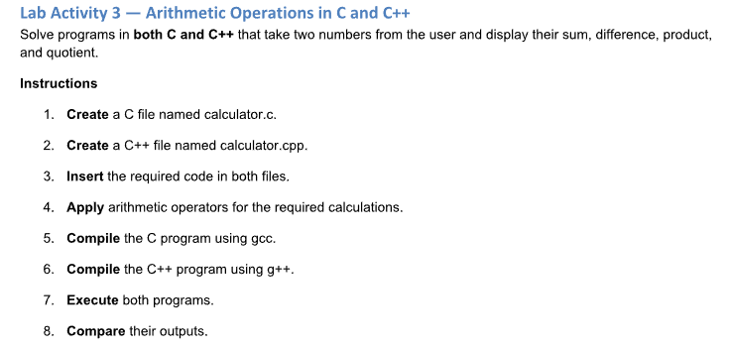

Working:
In this activity, we developed basic calculator programs in both C (calculator.c) and C++ (calculator.cpp). Both programs prompt the user to input two numeric values and calculate their sum, difference, product, and quotient. We compiled the C file using gcc and the C++ file using g++. Executing both programs confirmed that both languages yield identical mathematical output.
Commands & Code (C Program):
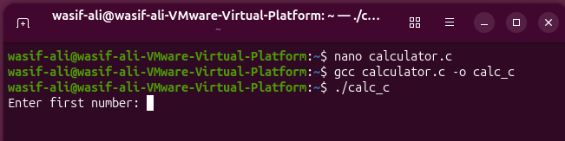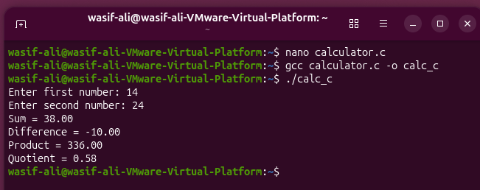
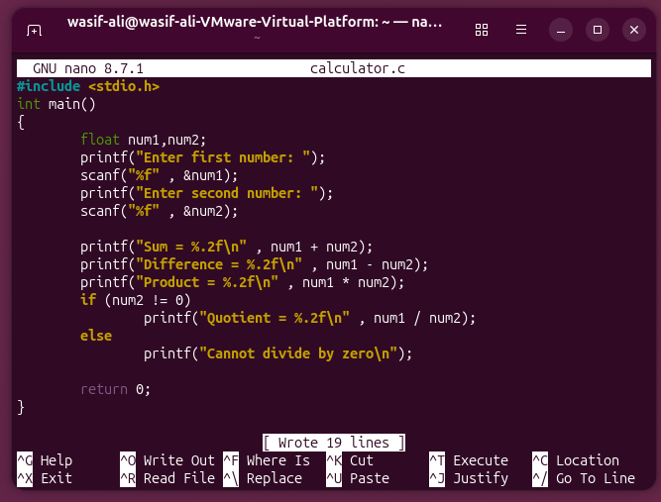

Commands & Code (C++ Program):

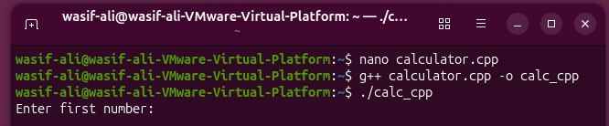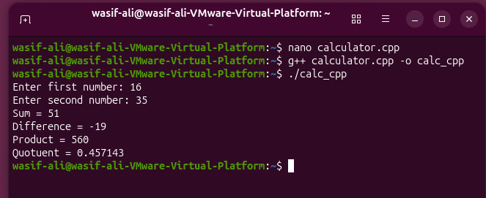
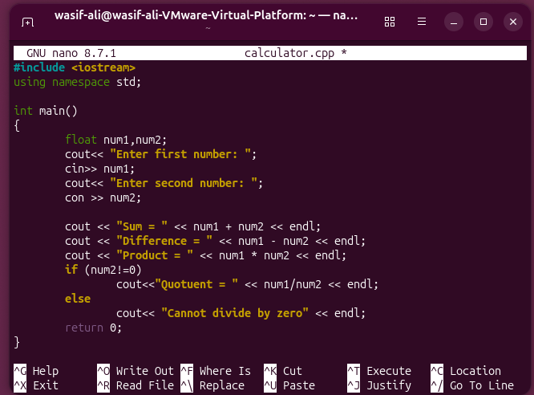

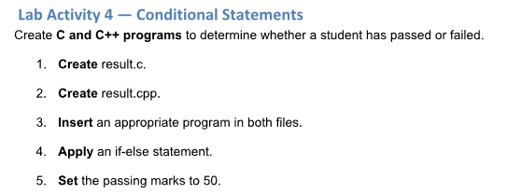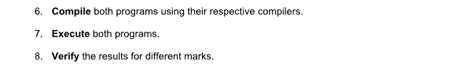

Working:
In this activity, we implemented conditional control structures in C (result.c) and C++ (result.cpp). The programs ask the user for student marks and evaluate them using an if-else condition with a passing mark threshold set to 50. Inputs of 50 or above display a "Pass" message, while inputs below 50 display "Fail".
Commands & Code (C Program):
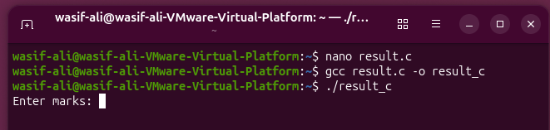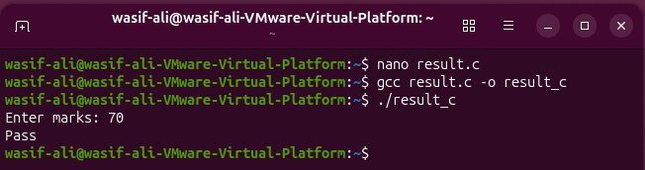
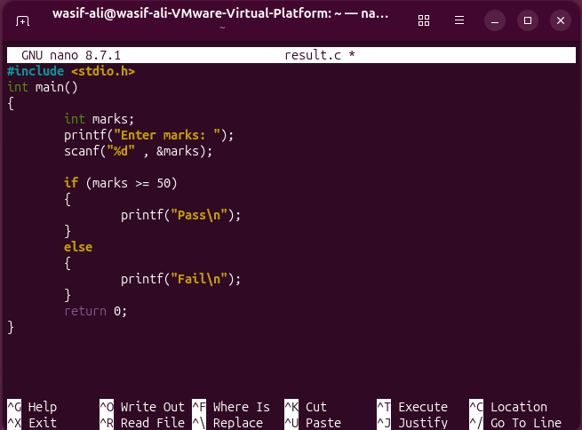

Commands & Code (C++ Program):

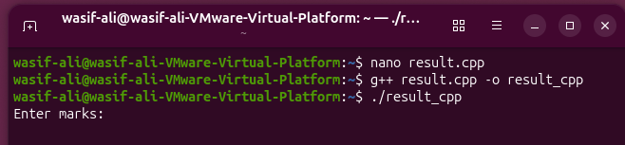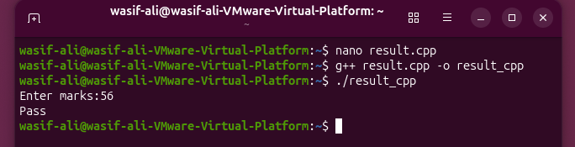
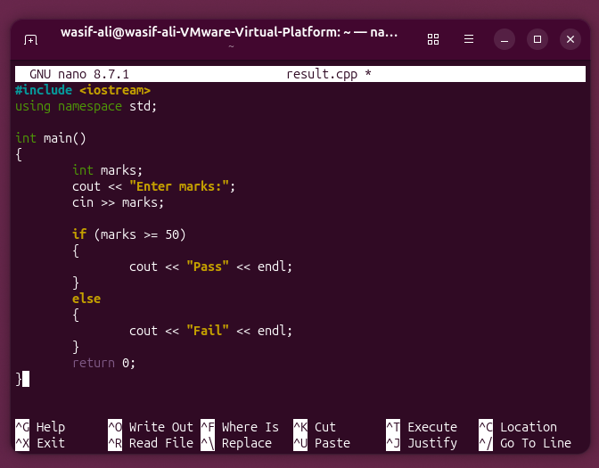
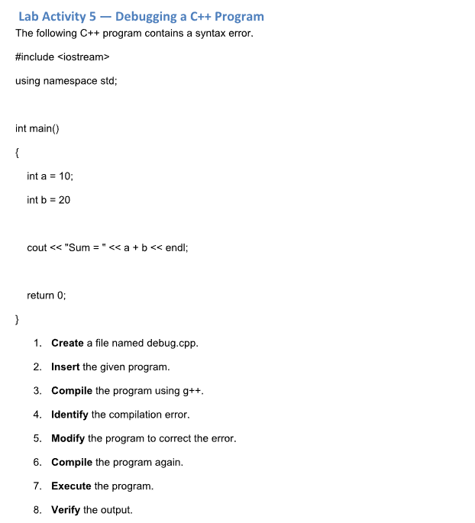
Working:
In this activity, we identified and corrected a syntax compilation error in a C++ source file named debug.cpp. The original code failed to compile due to a missing semicolon ; after the variable declaration int b = 20. We edited the file in nano, added the required semicolon, recompiled using g++, and executed the fixed program to verify the correct sum output.

Given Code:
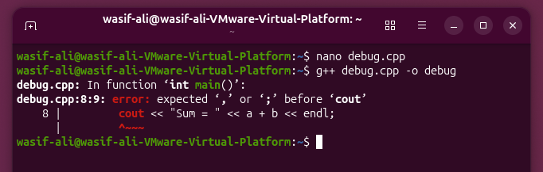
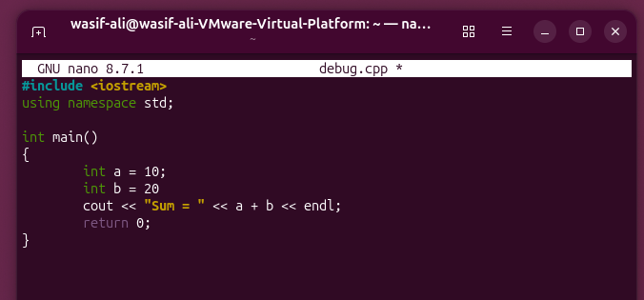
Corrected code:
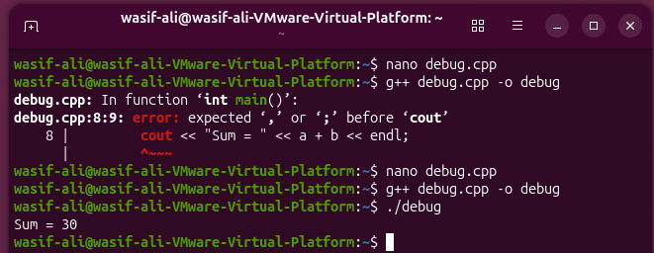
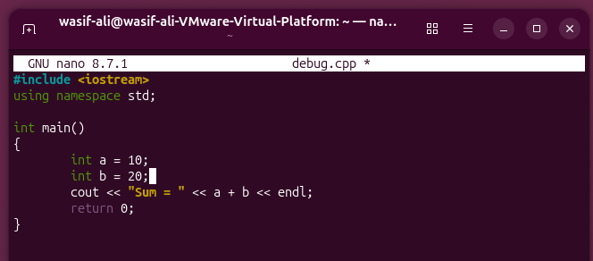
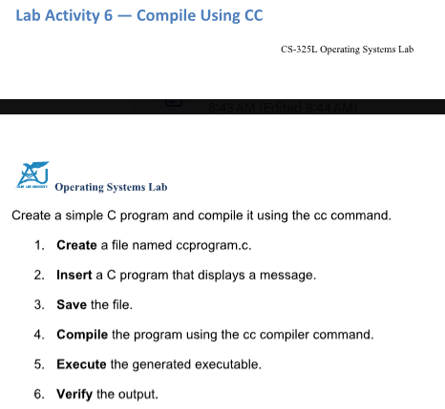
Working:
In this activity, we created a simple C program named ccprogram.c. Instead of using the gcc command directly, we compiled the file using cc, which is the system's default C compiler interface. Running the compiled binary demonstrated that the cc command successfully processes and builds C programs in Ubuntu.
